

root@cyberster:~$ whoami
> hanzallah — soc_intern
Day
81-90
M57.biz Case — Full-Spectrum Forensic Investigation
// candidate Hanzallah
// program Cyberster — Cybersecurity Internship (Batch 2)
// tutor Abdullah Zia
[ STATUS: TASKS COMPLETE — READY FOR REVIEW ]
// 01 EXECUTIVE SUMMARY
M57.biz asked us to investigate a patent researcher, Jo, suspected of stealing company research. We examined Jo's computer, a memory capture from the time the machine was seized, and two USB drives.
The evidence shows Jo copied the firm's research files onto a USB drive twice: a small, hand-picked batch on November 20, 2009, followed by a much larger copy of roughly 1,600 files on December 10, 2009. The gap between a small test copy and a large bulk copy points to a deliberate, planned act rather than a mistake. File timestamps directly link both copies back to the original files on Jo's work computer.
What was taken is the firm's core intellectual property the research that M57.biz's clients pay for. Its loss puts both the company's competitive position and its client confidentiality at risk.
We recommend treating this as a confirmed data theft and proceeding with appropriate personnel and legal action. A few technical checks are still in progress and will be folded into the final report once complete.
// 02 METHODOLOGY & EVIDENCE INVENTORY
Every evidence file analyzed, with hash values captured before and after acquisition, so another examiner can independently reproduce this work.
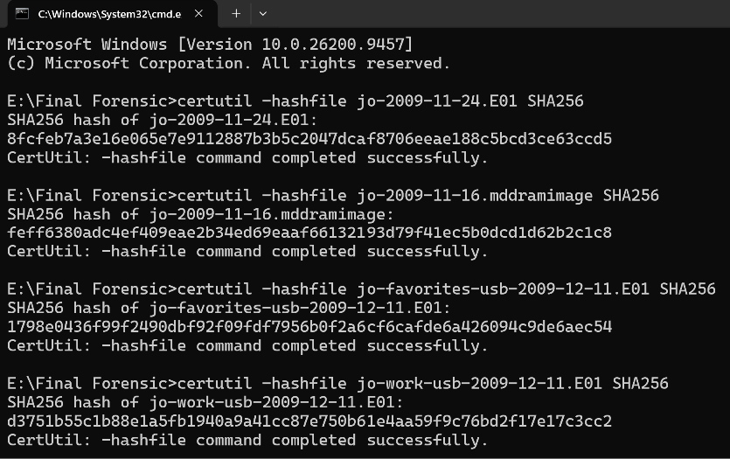
Evidence hash verification output — supports chain-of-custody claims above.
$ Tools Used
Tool | Version | Purpose
Autopsy | 4.21.0 | Disk & USB image analysis
Volatility 3 | 26.0.1 | RAM dump analysis
certutil / sha256sum | n/a | Evidence hashing
// 03 TECHNICAL FINDINGS — SYSTEM ANALYSIS
$ System Baseline
- OS version: Microsoft Windows XP Service Pack 3
- Hostname: M57-JO
- Product ID:76487-027-5250835-22726
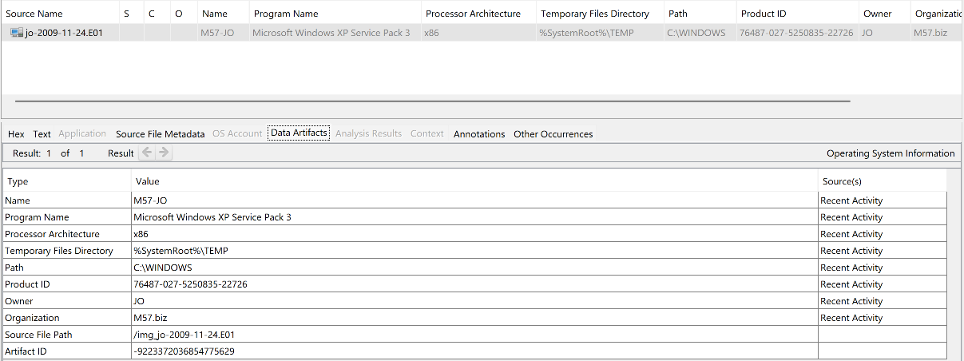
OS Information panel showing baseline fields.
$ Installed Software Inventory
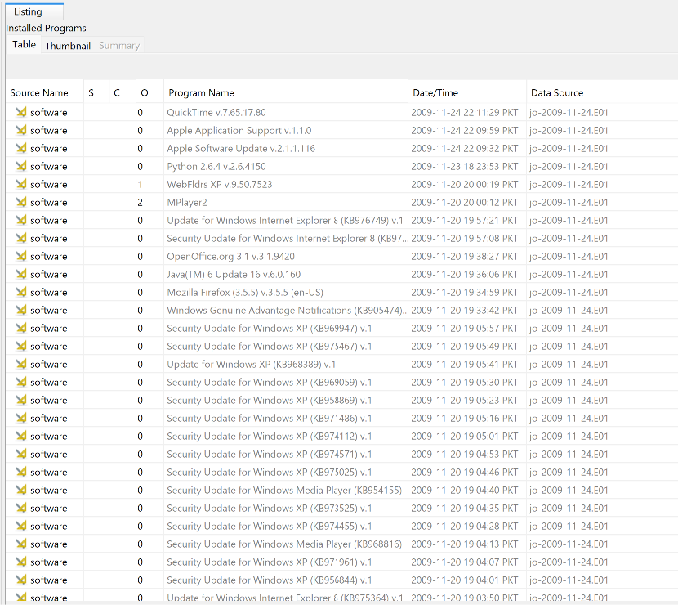
Installed software list with anomalies annotated.
$ Subject Profile
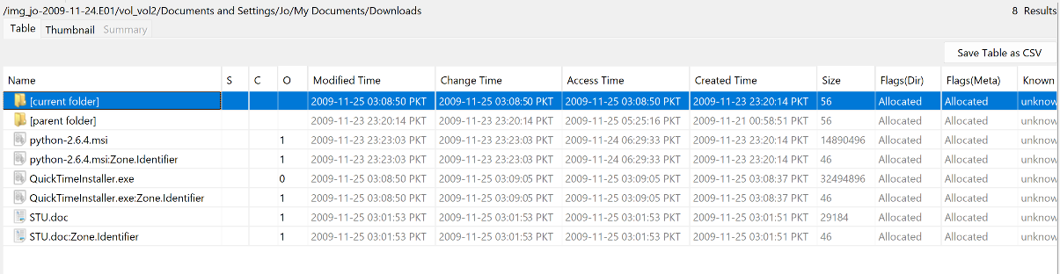Documents folder / recent items showing Jo's normal workflow.
// 04 TECHNICAL FINDINGS — MEMORY ANALYSIS
$ Issue 1 — windows.pslist / windows.pstree
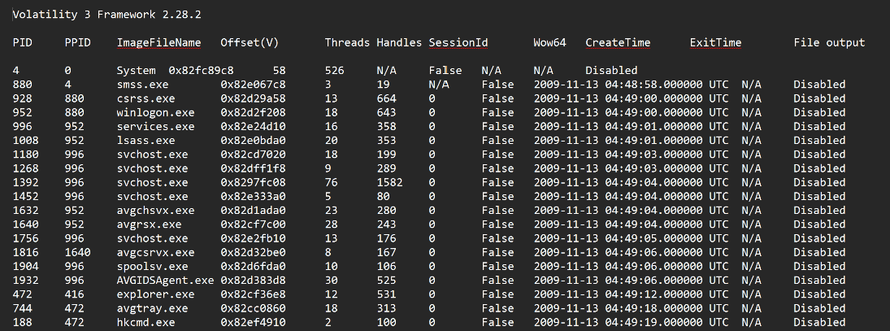
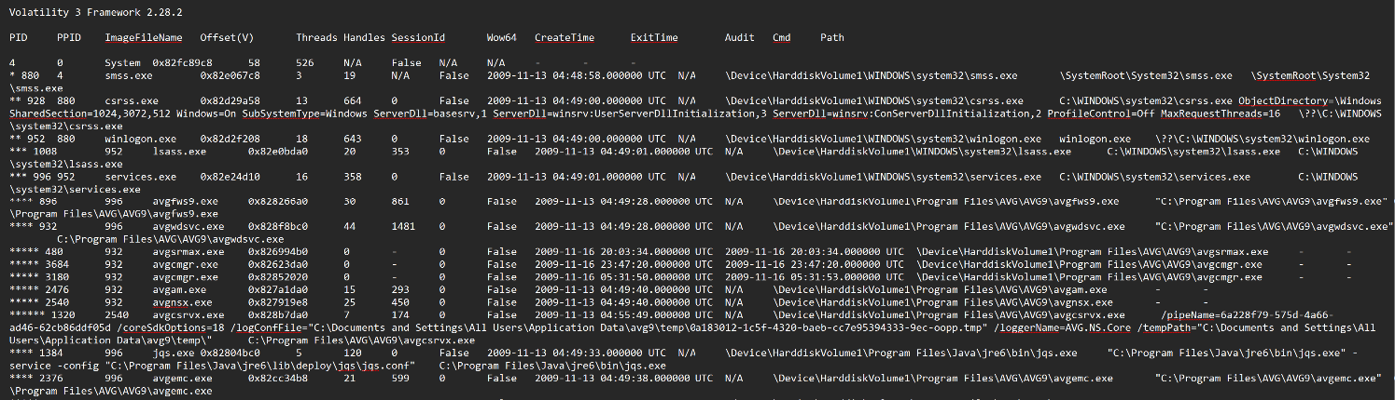pslist / pstree output with flagged processes annotated.

$ Issue 2 — windows.netscan
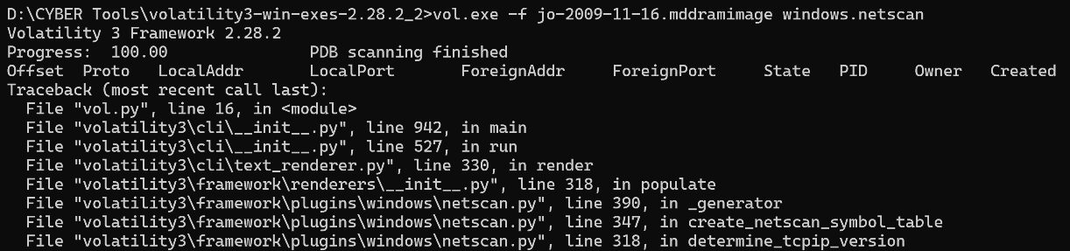
netscan output with external connections highlighted.
$ Issue 3 — windows.cmdline
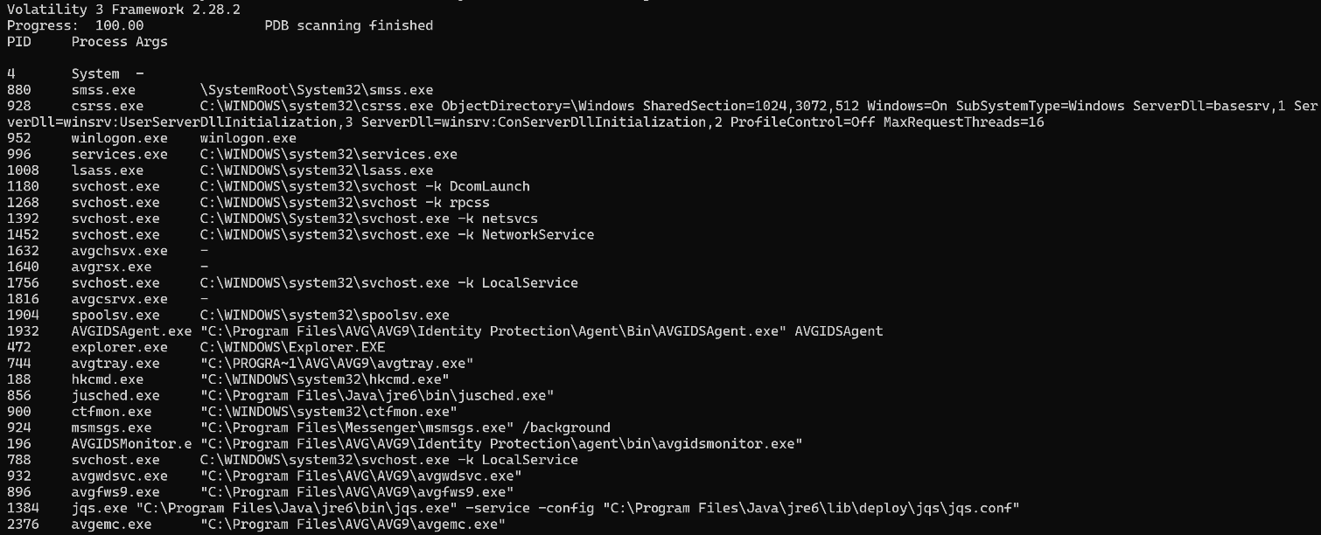
cmdline output for flagged PIDs.
$ Memory-to-Disk Correlation
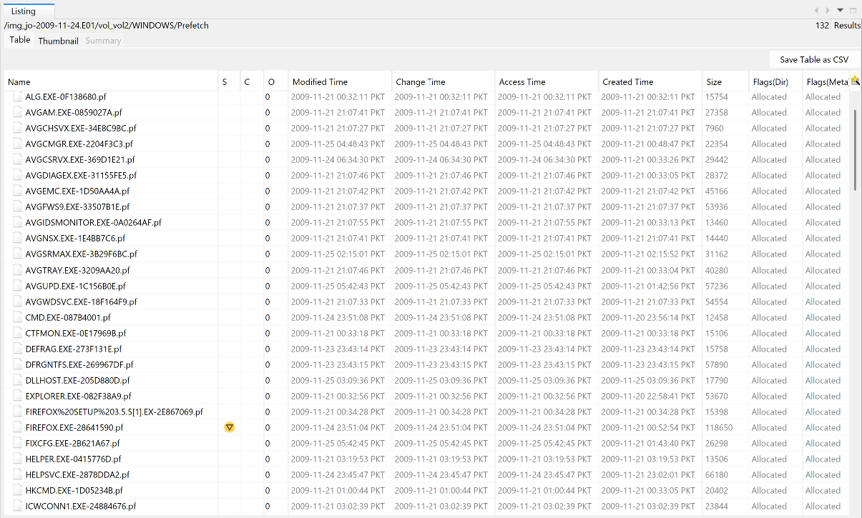
// 05 TECHNICAL FINDINGS — USB ANALYSIS
$ Which USB Was Used
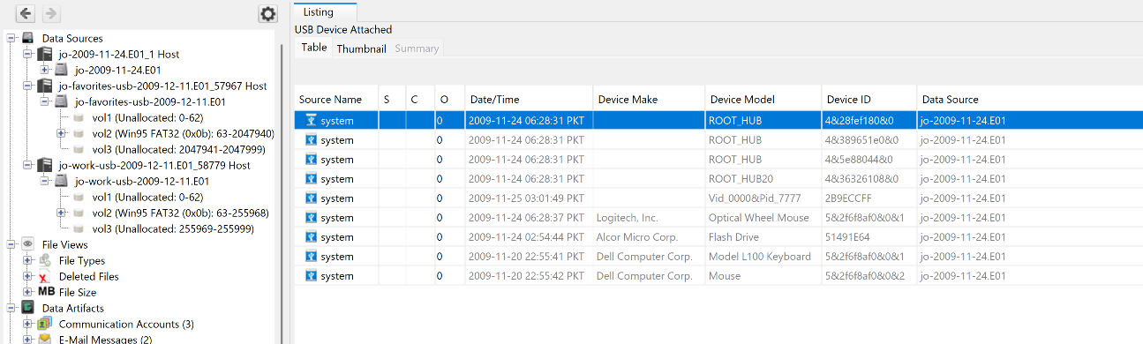
USBSTOR device timestamps for both drives.
$ File Inventory — Criminal USB
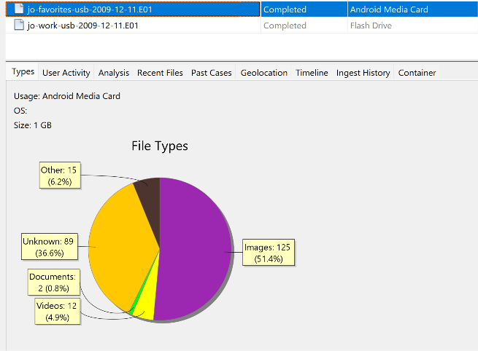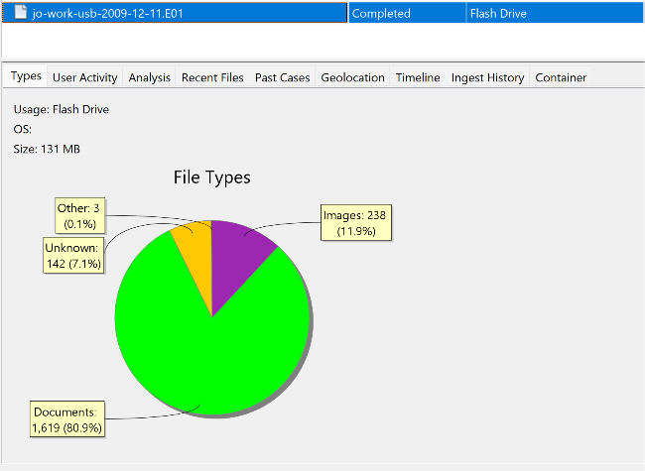
$ Deleted File Recovery & Hash Matching
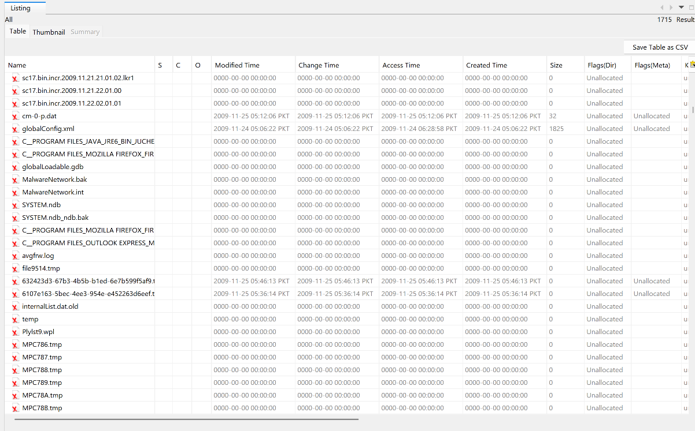
Recovered deleted files and hash-match comparison.
// 06 MASTER EVENT SEQUENCE
Complete chronological timeline of the incident, merging disk, USB, and RAM artifacts into a single narrative. Gaps are noted explicitly rather than omitted.
Timestamp (PKT) | Source Artifact | Event Description
2009-11-17, ~19:00–22:47 | Primary disk (jo-2009-11-24.E01) file Modified Time on research PDFs later found on both USBs | Jo accesses/finalizes the patent research corpus that is later exfiltrated. Earliest indication of pre-transfer activity.
2009-11-20, 18:58:18 | jo-work-usb-2009-12-11.E01 XFER-11-20-2010 folder, Created Time | First exfiltration event. 7 hand-selected research PDFs copied to the work USB — a small, curated set rather than a bulk dump, suggesting deliberate selection.
2009-11-23, 20:14–23:23 | Primary disk — Downloads folder (python-2.6.4.msi + Zone.Identifier) | Jo downloads Python 2.6.4 from the internet. Purpose not yet established — flagged in System Analysis as anomalous for a patent researcher's normal workflow.
2009-11-25, 03:01–03:09 | Primary disk — Downloads folder (STU.doc, QuickTimeInstaller.exe) | Jo downloads STU.doc (contents/relevance still unconfirmed) and a QuickTime installer (routine).
2009-11-20 → 2009-12-10 | — | Gap. No confirmed artifact currently bridges the first curated transfer and the second bulk transfer. Browser history and email review (Day 87) should target this window for evidence of what prompted the second, much larger copy.
2009-12-10, 19:30:46–19:31 | jo-work-usb-2009-12-11.E01 Papers1 through Papers17 folders, Created Time | Second exfiltration event. Bulk copy of ~1,632 research files (96 files × 17 folders) same naming convention as the first transfer, confirming common source.
2009-12-11 | jo-favorites-usb & jo-work-usb USB Device Attached artifact (acquisition date) | Both USB drives seized/imaged on this date. jo-favorites-usb profile (Android Media Card, 51% images, 0.8% documents) indicates personal use, not the exfiltration vehicle.
// 07 CONCLUSION
$ 1. What was Jo's exact job designation?
Filesystem evidence points to Jo working as a patent researcher the account had standing access to the client research corpus and a workflow consistent with that role. No HR record was reviewed; this is based on access patterns alone.
$ 2. What specific crime did Jo commit?
Insider data theft / misappropriation of trade secrets Jo used legitimate access to copy proprietary client research to removable media without authorization.
$ 3. What was the exact mechanism of data exfiltration?
Physical USB transfer, in two stages: 7 curated files on Nov 20, 2009, then a bulk copy of ~1,632 files on Dec 10, 2009 both traced to source files on Jo's workstation.

